

Lab Report No 2

**Logic Gates Applications**

**_____________________________**

**Group No 5**

**CS-202L-Digital Logic Design Lab**

**Department of Computer System Engineering**

**University of Engineering and Technology Peshawar**

Submitted to: **Engr. Rehmat Ullah**

Submitted by:

**Muhsin Shah (2018)**

**Muhammad Zaid (1991)**

**Muhammad Saad (1997)**

**DCSE, Batch 23, Section “B”**



**Objective:**

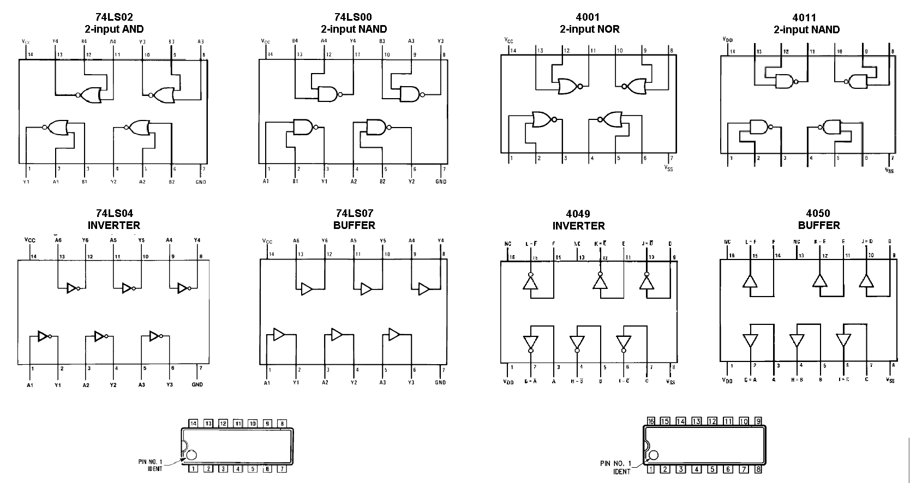

* The object of this lab is to test the output of different logic gate ICs with LEDs.

**Apparatus:**

* DC power supply
* Breadboard
* Connecting wires
* LED
* Logic Gates ICs
  + - NOT gate 7404
    - OR gate 7432
    - AND gate 7408
    - NOR gate 7402
    - NAND gate 7400
    - XOR gate 7486

Fig 01: Integrated Circuits



Fig 02: Integrated Circuits

**Procedure:**

1. First we will power on our power supply and connect two wires from it to our circuit board, one 5 volts and one ground or 0 volt.
2. Then we will start our testing by taking inputs from 5 volts or 0 volt as high and low respectively and connect them to the input of the gates. In case of NOT gate there is only one input and for every other gate there are two.
3. After this we will take output of the gate and connect it to the LED,s positive leg and other one is already grounded.
4. All the gates should give the result according to the truth table i.e where there is “1” in the truth table, the LED will glow and “0”, it will not glow. Following are the results that we found for some gates in Lab while doing the experiment.

**Exclusive OR (XOR) gate:**

Standalone IC for XOR gate is rare. But it can be made by using AND, OR and NOT gates. Below is the circuit diagram for XOR gate and also the truth table of the results from the experiments performed.

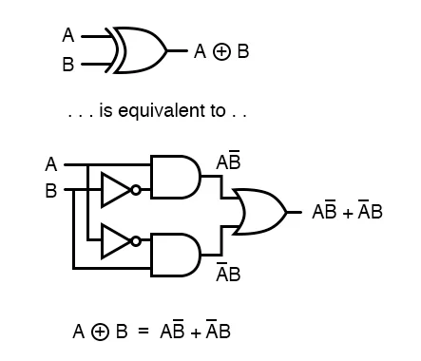

|  |  |  |
| --- | --- | --- |
| A | B | F(A, B) |
| 0 | 0 | 0 |
| 0 | 1 | 1 |
| 1 | 0 | 1 |
| 1 | 1 | 0 |

XOR Gate Readings

Fig 03: XOR gate Circuit

For 1 the LED glows and for 0 it does not.